SQL Joins:
The SQL JOIN joins two tables based on a common column and selects records that have matching values in these columns.
Example:
-- join the Customers and Orders tables
-- based on the common values of their customer_id columns
SELECT Customers.customer_id, Customers.first_name, Orders.item
FROM Customers
JOIN Orders
ON Customers.customer_id = Orders.customer_id;
Example 1: SQL JOIN
-- join Customers and Orders tables based on
-- customer_id of Customers and customer column of Orders
SELECT Customers.customer_id as ID, Customers.first_name, Orders.amount
FROM Customers
JOIN Orders
ON Customers.customer_id = Orders.customer;
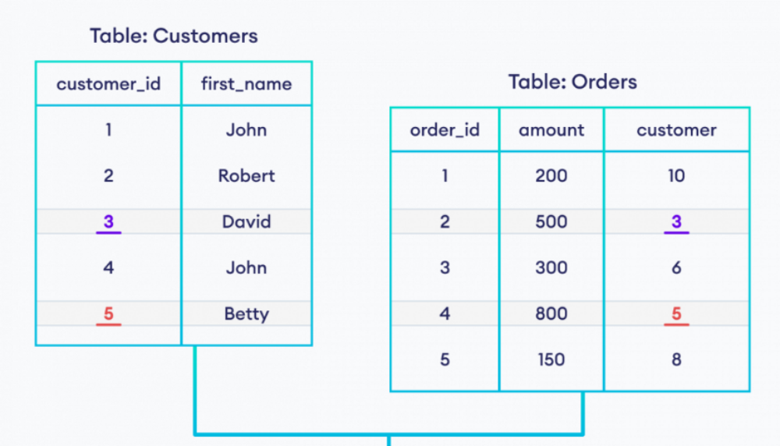


Types of SQL JOINs
As we mentioned, the JOIN command we performed in this article is INNER JOIN.
In SQL, we have four main types of joins:
INNER JOIN
LEFT JOIN
RIGHT JOIN
FULL OUTER JOIN
SQL JOIN and Aliases
We can use AS aliases with table names to make our query short and clean. For example,
-- use alias C for Customers table
-- use alias O for Orders table
SELECT C.customer_id, C.first_name, O.amount
FROM Customers AS C
JOIN Orders AS O
ON C.customer_id = O.customer;
Also, we can change the column names temporarily using AS aliases. For example,
-- use alias C for Customers table
-- use alias O for Orders table
SELECT C.customer_id AS cid, C.first_name AS name, O.amount
FROM Customers AS C
JOIN Orders AS O
ON C.customer_id = O.customer;
INNER JOIN
The SQL INNER JOIN command joins two tables based on a common column and selects rows with matching values in those columns.
Example
-- join Customers and Orders tables
-- select customer_id and first_name columns from the Customers table
-- select amount from the Orders table
SELECT Customers.customer_id, Customers.first_name, Orders.amount
FROM Customers
INNER JOIN Orders
ON Customers.customer_id = Orders.customer;
SQL INNER JOIN Syntax
The syntax of the SQL INNER JOIN statement is:
SELECT columns_from_both_tables
FROM table1
INNER JOIN table2
ON table1.column1 = table2.column2
Example 1: SQL INNER JOIN
-- join the Customers and Orders tables when
-- the customer_id from Customers matches the customer column in Orders
SELECT Customers.customer_id, Customers.first_name, Orders.amount
FROM Customers
INNER JOIN Orders
ON Customers.customer_id = Orders.customer;
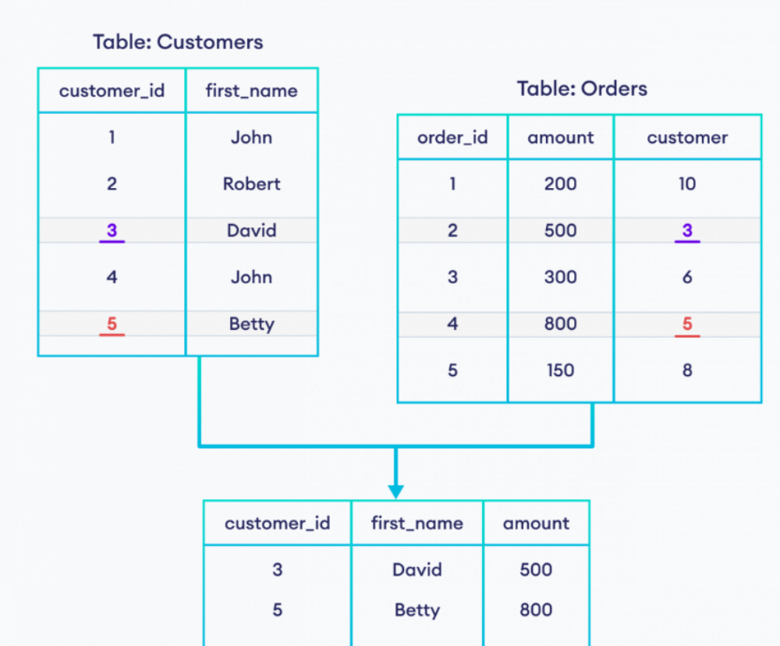
Example 2: SQL INNER JOIN
Let's look at another example.
SELECT Categories.cat_name, Products.prod_title
FROM Categories
INNER JOIN Products
ON Categories.cat_id = Products.cat_id;
INNER JOIN With WHERE Clause
We can use the WHERE clause in conjunction with an INNER JOIN to further filter the rows in the output.
-- join tables the Customers and Orders tables
-- return rows if amount is 500 or higher

SELECT Customers.customer_id, Customers.first_name, Orders.amount
FROM Customers
INNER JOIN Orders
ON Customers.customer_id = Orders.customer
WHERE Orders.amount >= 500;
SQL LEFT JOIN
The SQL LEFT JOIN joins two tables based on a common column. It selects records that have matching values in these columns and the remaining rows from the left table.
Example
-- left join Customers and Orders tables based on their shared customer_id columns
-- Customers is the left table
-- Orders is the right table
SELECT Customers.customer_id, Customers.first_name, Orders.item
FROM Customers
LEFT JOIN Orders
ON Customers.customer_id = Orders.customer_id;
Example: SQL LEFT Join
-- left join the Customers and Orders tables
SELECT Customers.customer_id, Customers.first_name, Orders.amount
FROM Customers
LEFT JOIN Orders
ON Customers.customer_id = Orders.customer;
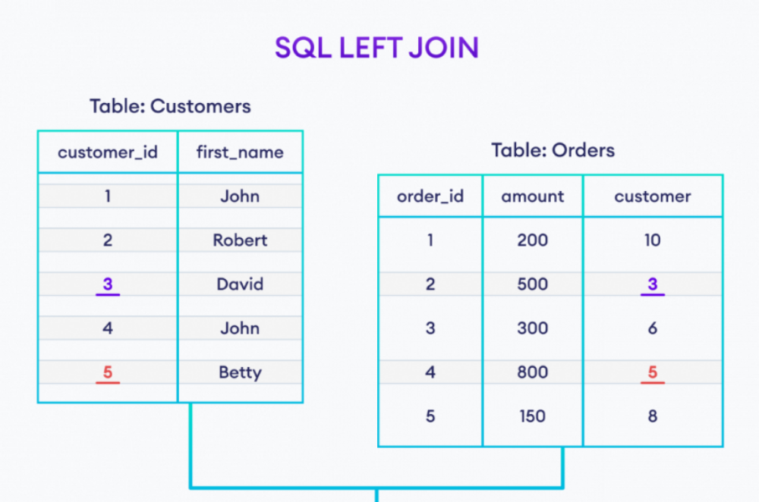
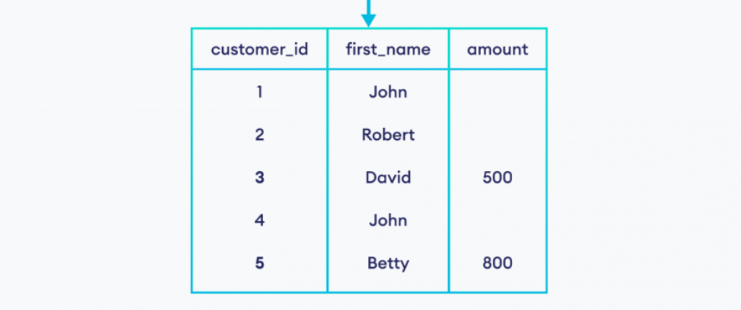
LEFT JOIN With WHERE Clause
The SQL LEFT JOIN statement can have an optional WHERE clause. For example,
SELECT Customers.customer_id, Customers.first_name, Orders.amount
FROM Customers
LEFT JOIN Orders
ON Customers.customer_id = Orders.customer
WHERE Orders.amount >= 500;
SQL RIGHT JOIN
The SQL RIGHT JOIN statement joins two tables based on a common column. It selects records that have matching values in these columns and the remaining rows from the right table.
Example
-- join Customers and Orders tables
-- based on their shared customer_id columns
-- Customers is the left table
-- Orders is the right table
SELECT Customers.customer_id, Customers.first_name, Orders.item
FROM Customers
RIGHT JOIN Orders
ON Customers.customer_id = Orders.customer_id;
RIGHT JOIN SYNTAX
The syntax of the SQL RIGHT JOIN statement is:
SELECT columns_from_both_tables
FROM table1
RIGHT JOIN table2
ON table1.column1 = table2.column2
Example: SQL RIGHT JOIN
-- join Customers and Orders tables
-- based on customer_id of Customers and customer of Orders
-- Customers is the left table
-- Orders is the right table
SELECT Customers.customer_id, Orders.amount
FROM Customers
RIGHT JOIN Orders
ON Customers.customer_id = Orders.customer;
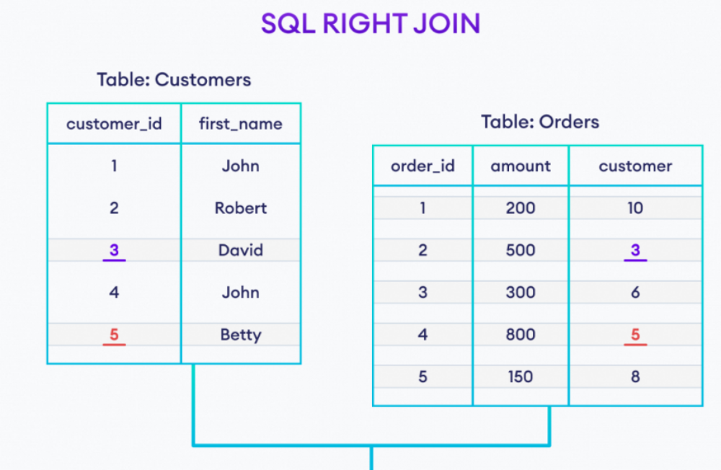
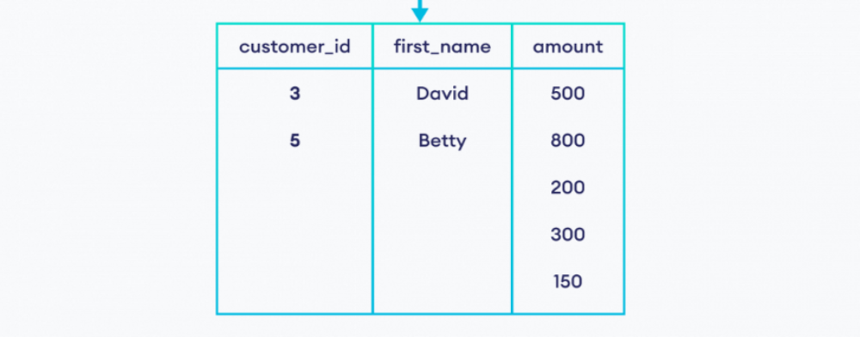
RIGHT JOIN With WHERE Clause
The SQL RIGHT JOIN statement can have an optional WHERE clause. For example,
SELECT Customers.customer_id, Customers.first_name, Orders.amount
FROM Customers
RIGHT JOIN Orders
ON Customers.customer_id = Orders.customer
WHERE Orders.amount >= 500;
SQL RIGHT JOIN With AS Alias
We can use AS aliases inside RIGHT JOIN to make our SQL code short and clean. For example,
-- use alias C for Categories table
-- use alias P for Products table
SELECT C.category_name, P.product_title
FROM Categories AS C
RIGHT JOIN Products AS P
ON C.cat_id = P.cat_id;
SQL FULL OUTER JOIN
The SQL FULL OUTER JOIN statement joins two tables based on a common column. It selects records that have matching values in these columns and the remaining rows from both of the tables.
Example
-- full join Customers and Orders tables
-- based on their shared customer_id columns
-- Customers is the left table
-- Orders is the right table
SELECT Customers.customer_id, Customers.first_name, Orders.item
FROM Customers
FULL OUTER JOIN Orders
ON Customers.customer_id = Orders.customer_id;
FULL OUTER JOIN SYNTAX
The syntax of the SQL FULL OUTER JOIN statement is:
SELECT columns
FROM table1
FULL OUTER JOIN table2
ON table1.column1 = table2.column2;
Example: SQL OUTER Join
SELECT Customers.customer_id, Customers.first_name, Orders.amount
FROM Customers
FULL OUTER JOIN Orders
ON Customers.customer_id = Orders.customer;
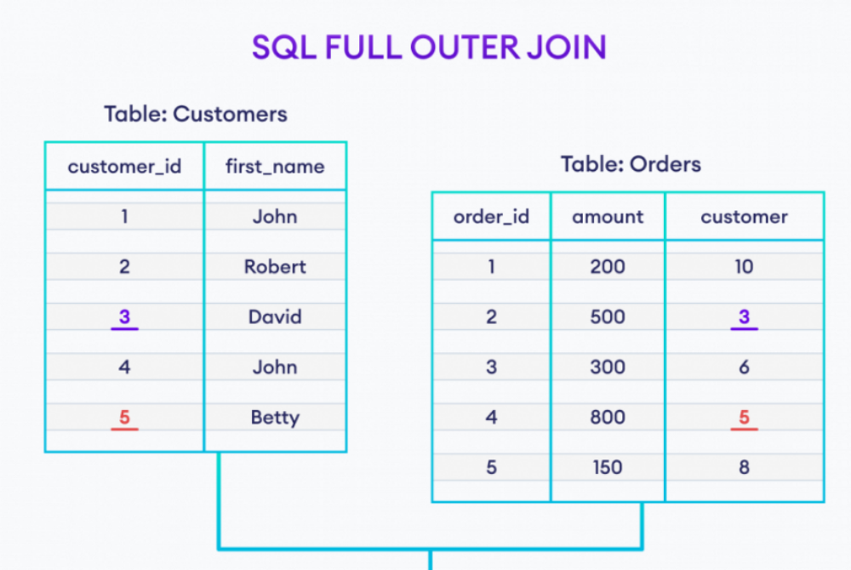
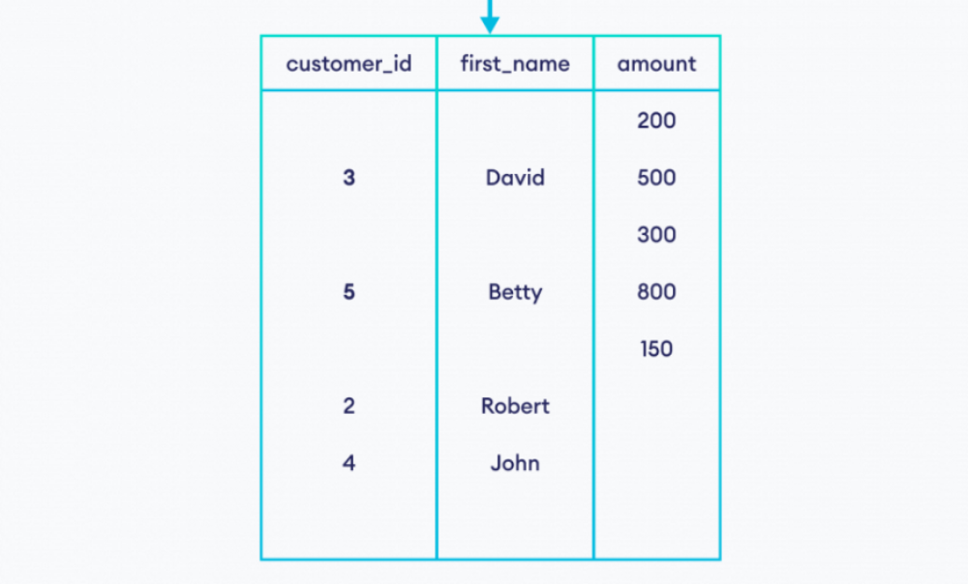
FULL OUTER JOIN With WHERE Clause
The SQL FULL OUTER JOIN statement can have an optional WHERE clause. For example,
SELECT Customers.customer_id, Customers.first_name, Orders.amount
FROM Customers
FULL OUTER JOIN Orders
ON Customers.customer_id = Orders.customer
WHERE Orders.amount >= 500;
Here, the SQL command joins two tables and selects rows where the amount is greater than or equal to 500.

